How to Use the CIRB Updates Tab on the CTSU Website as a Replacement for the Retired Website Posting Summary

A new tab titled “CIRB Updates” was added to the homepage of the secured CTSU Members area of the CTSU website in May 2015 and replaces the CIRB’s bi-monthly Website Postings Summary. The CIRB Updates tab (red arrow) provides a real-time list of postings made by the CIRB Operations Office to the CTSU website. One of the main advantages of the real-time posting interface is that users now have the option to check on the list of current review postings made to the CTSU on their own schedule.

Users will need to log into the CTSU website to gain access to the CTSU Members area to view the new CIRB Updates tab.

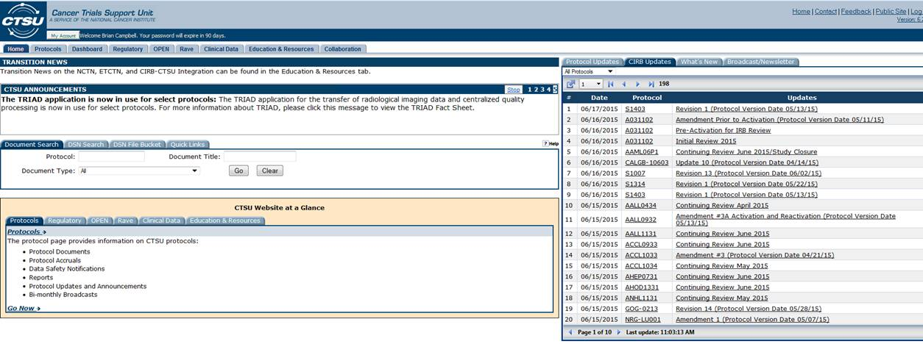

The new interface is designed to list new and updated postings made to CIRB reviewed studies by: Date, the date the event was posted to the CTSU website (orange arrow); Protocol, the study ID for the protocol (green arrow); and Updates, the event name that CIRB review documents were posted under (blue arrow). To sort by any of these three categories, click on the column heading (Date, Protocol, or Updates) in the top row of the CIRB Updates table.

Users should review the list for studies open at their institution and then click on the event name link under the “Updates” column to see a listing of the documents that were posted to the CTSU website for that event on the date specified. Clicking on the link under the “Updates” column opens a pop-up window showing the documents associated with that event.
For example: Revision 1 for S1403 was posted to the CTSU website on 06/16/2015.

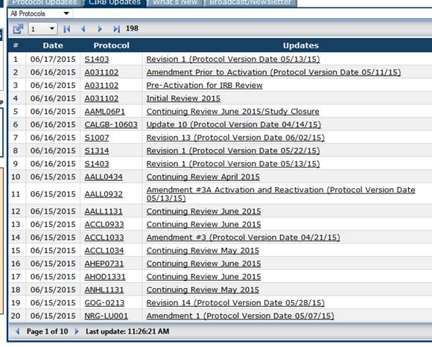

Clicking the Revision 1 link opens a pop-up window listing the new documents posted to the CTSU website on 6/16/2015 for this event.
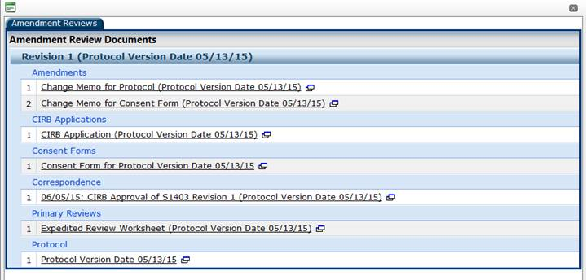

There are times when an event will have two distinct posting dates. This happens when additional documents are added to the posting at a later date, such as finalized minutes.

For example, a second posting for S1403 Revision 1 was done on 6/17/2015.

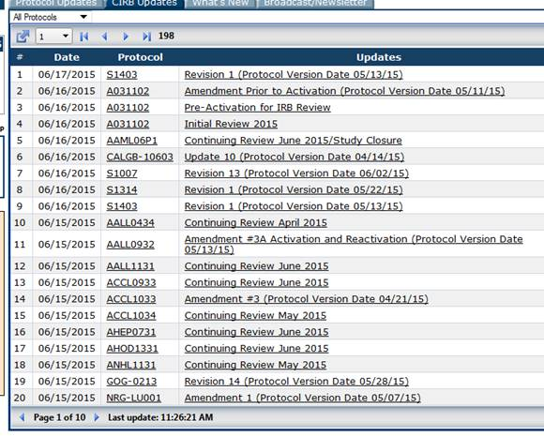

Clicking the Revision 1 link for the 06/17/2015 entry opens a new pop-up window showing the specific documents posted to the event on 6/17/2015.

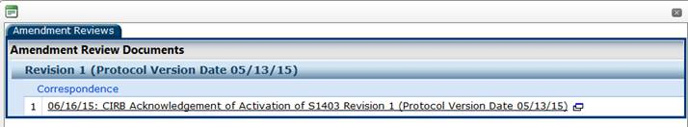

Users can also go directly to the protocol page by clicking the study ID link under the Protocol column to be taken to the main protocol page to review the complete set of CIRB documents for individual studies.

Once on the main study page, users can navigate to the CIRB Documents tab (red arrow) to get access to the complete set of CIRB documents. The CIRB Details table (orange arrow) lists the most current CIRB-approved, Group-activated version of protocol and consent form(s). Study reviews are grouped under three distinct tabs: Initial Reviews, Amendment Reviews, and Continuing Reviews (green arrow). The Initial Reviews tab includes the initial study review, protocol amendments reviewed prior to activation, and the final activation notice. The Amendment Reviews tab includes all post-activation protocol amendments, memos and patient recruitment notices. The Continuing Reviews tab includes the annual continuing review determinations.

Only reviews approved since June 2013 are available on the CTSU website. All reviews approved before June 2013 are available on the Participant’s Area of the NCI CIRB website.

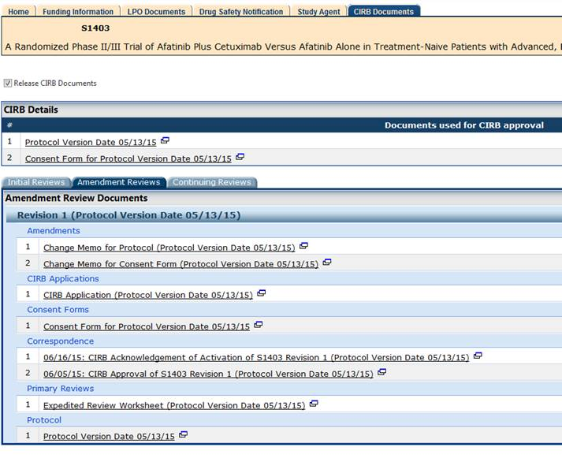.

For those wishing to mirror the old bi-monthly Website Postings Summary, the CIRB Operations Office suggests exporting the contents of the CIRB Updates tab in Excel format on the 1st and 15th of each month. The listing can be downloaded and sorted by the preferred sort criteria using the step-by-step instructions outlined below:

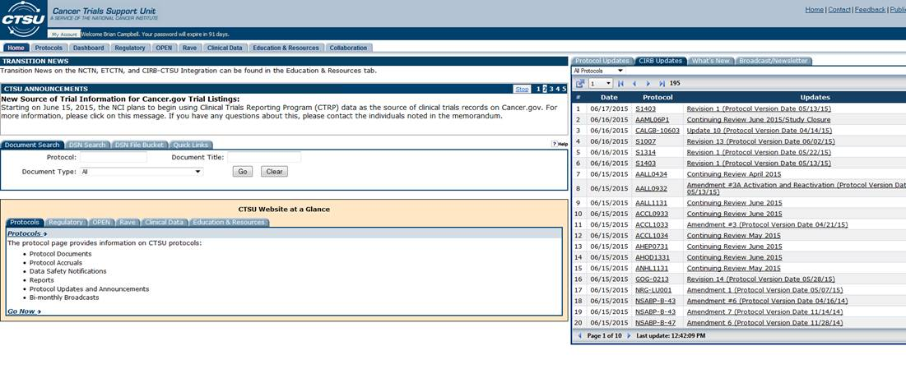
If you click on the icon (red arrow), you will get a dropdown list of export options. The export function supports downloading the complete posting list in Excel, PDF, or CSV formats (green arrow).
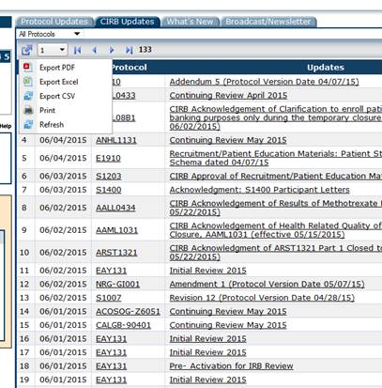

If you click the Export Excel option, a window will open asking whether to save or open the file.

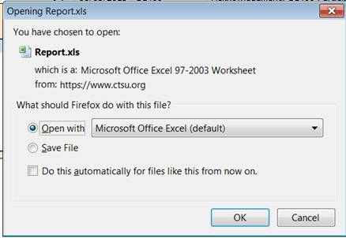

If you select Open, a complete listing of all CIRB Updates will appear. You can then sort/filter by the preferred Date range to meet your requirements. The CTSU website works best with Chrome as the browser. If you are using a current version of Firefox or Internet Explorer, you may need to close out your browser and restart it to make additional downloads.

The Excel spreadsheet will automatically sort by Date, the date the update was posted to the CTSU website (most recent to oldest). Users can also sort by Protocol or by Update event name. New Study and Continuing Review update events have a common naming schema, New Study reviews are always named “Initial Review <month> <year>”; Continuing Reviews are always name “Continuing Review <month> <year>. You can sort the file by Updates if you need to focus on these two event types.

