Memorandum

To: Principal Investigators and Research Staff at Institutions enrolled in the CIRB Initiative

From: John D. Horigan
CIRB Administrator; NCI CIRB Operations Office

Date: May 1, 2015

Subject: CIRB Postings Summary Now Available on CTSU Website

As of Monday, May 4, 2015, the summary of CIRB postings will be available on the CTSU website in real time. The real time listing will be available on the right side of the CTSU password-protected homepage under the CIRB Updates tab. The listing includes the date posted, the protocol ID, the event name, and a link to the associated documents. Screenshots to orient you to this new feature are included at the end of this memo.

The CIRB will discontinue the bimonthly Website Postings Summary email. To view a listing of archived copies of the Website Postings Summary, click on the Website Postings Summary link located in the menu bar of the NCI CIRB website (www.ncicirb.org).

Contact the NCI CIRB Helpdesk at NCICIRBContact@emmes.com with any questions.

New CIRB Updates Tab.
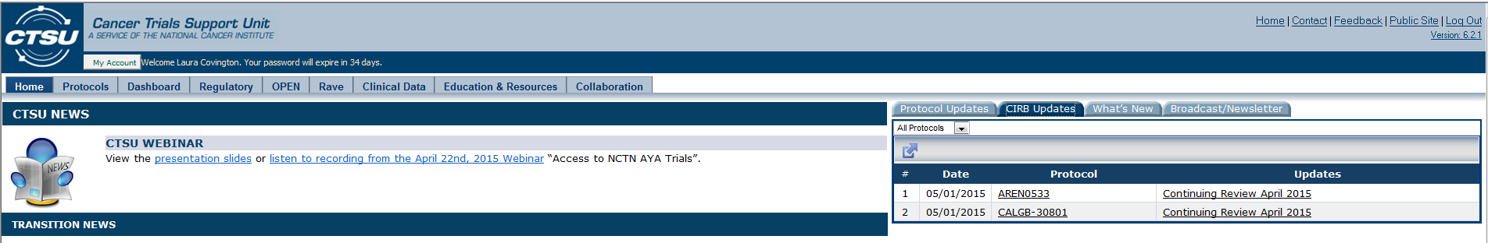

Close-Up View of New CIRB Updates Tab.
