**OMB #0925- 0753 Expiration  Date: 06/30/2020**

Collection of this information is authorized by The Public Health Service Act, Section 411 (42 USC 285a). Rights of your participation in the NCI CIRB is protected by The Privacy Act of 1974. Participation is voluntary, and there are no penalties for not participating or withdrawing from the NCI CIRB at any time. Refusal to participate will not affect your benefits in any way. The information collected will be kept private to the extent provided by law. Names and other identifiers will not appear in any report of the NCI CIRB. Information provided will be combined for all participants and reported as summaries. You are being requested to complete this instrument so that we can conduct activities involved with the operations of NCI CIRB Initiative.

**NOTIFICATION TO RESPONDENT OF ESTIMATED BURDEN**Public reporting burden for this collection of information is estimated to average 20 minutes per response, including the time for reviewing instructions, searching existing data sources, gathering and maintaining the data needed, and completing and reviewing the collection of information. **An agency may not conduct or sponsor, and a person is not required to respond to, a collection of information unless it displays a currently valid OMB control number.** Send comments regarding this burden estimate or any other aspect of this collection of information, including suggestions for reducing this burden, to: NIH, Project Clearance Branch, 6705 Rockledge Drive, MSC 7974, Bethesda, MD 20892-7974, ATTN: PRA (0925-0625*). Do not return the completed form to this address.

**Annual Principal Investigator Worksheet**

Reason for submission:

First Submission of the Annual Principal Investigator Worksheet

Revised Submission of the Annual Principal Investigator Worksheet

**Signatory Institution Information**

Submitting User Information (auto-populated)

1. Enter Principal Investigator email address.

2. Name of Signatory Institution (auto-populated)

**Research Staff**

3. How many sub-investigators do you have supporting you in conducting CIRB-approved research?

4. How many research nurses/CRAs do you have supporting you in conducting CIRB-approved research?

5. Have you or any of your research staff reported a financial conflict of interest related to any studies on the CIRB menu that resulted in a management plan?

Yes

No

If Yes, attach the institutionally-approved management plan.

NOTE: Principal Investigator Education, Training, and Experience

No additional information is required. Information pertaining to investigator education, training, and experience is captured annually through the NCI Investigator Registration.

**Principal Investigator Resources**

6. How many actively accruing research studies, for which you are the PI, do you have open, including CIRB-approved and those not reviewed by the CIRB?

a. List CIRB-approved studies by Study ID Number.

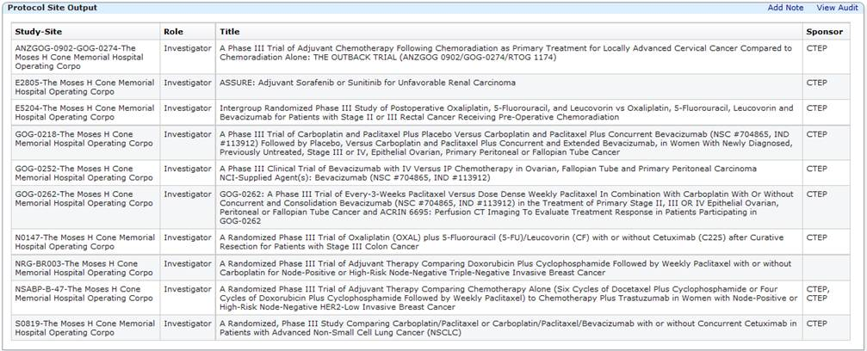

7. How many study participants are currently receiving study intervention for studies for which you are the PI?

**Recruitment**

8. Identify recruitment methods usually used:

Network Group/sponsor-supplied handouts

Locally developed recruitment materials

Other (social media, websites, etc.)

NOTE: Study-specific material requires CIRB approval and should be submitted using the Annual Signatory Institution Worksheet or Study-Specific Worksheet

Please describe.

9. Indicate how potential study participants are identified for CIRB-approved studies.

Using recruitment materials as indicated in question 8.

Through usual clinical practice.

Referrals from other providers.

Using a separate IRB-approved screening protocol (reviewed and approved by another IRB)

NOTE: When a protocol includes study-specific recruitment activities, these activities are approved as part of the CIRB’s approval of the study and need not be recorded on this worksheet.

**Compensation to Study Participants**

10. The CIRB is aware that there is typically no compensation provided for CIRB-studies to study participants for CIRB-approved studies. Describe any compensation/incentives provided by the Signatory Institution or others to study participants enrolled in CIRB-approved studies other than reimbursements that are part of the study, for example: parking validation, cafeteria voucher, other.

**Informed Consent Process**

Answer the following questions regarding the process used to introduce a trial to a potential study participant and obtain their informed consent.

11. Where does the consent discussion take place?

12. Who is authorized to obtain consent?

13. How long does the potential study participant have to review the consent document before a response is required, including time to take the consent document home?

14. Who is available to answer questions?

15. How is the potential study participant’s understanding of consent assessed?

16. How is the informed consent process conducted with non-English speaking potential study participants?

17. Who provides consent?

Potential study participant

Parent for potential pediatric study participant

Legally Authorized Representative

Other

Please explain.

18. For what languages are translations routinely provided?

If translations are routinely provided, what process is currently used to translate the informed consent document?

If applicable, an attachment can be added here.

19. Describe your institution’s policy regarding assent by children or impaired adults.

NOTE: The CIRB makes a determination regarding the requirement for assent and the age determination. Institutions enrolling children must obtain assent from any child in the age range determined by the CIRB. The documentation of the assent is per local policy and should be described here. If a child in the age range determined by the CIRB cannot provide assent, an assent waiver must be requested from the CIRB and obtained prior to enrollment of the child.

If applicable, an attachment can be added here.

20. Describe your institution’s process to receive and address concerns from study participants and others about the conduct of the research.

**Pharmacy Information**

21. Will the drugs/agents used in your studies be managed by a pharmacist?

If a pharmacist will be managing the drugs/agents used in the study, provide the name and title of the pharmacist at each practice location where research will be conducted.

If the drugs/agents will not be managed by a pharmacist, provide the name and title of the responsible person for the drugs/agents at each practice/location where research will be conducted.

22. How is the pharmacist provided with a copy of the protocol at each practice location?

**Measures to Protect Confidentiality**

Confidentiality is defined as the study participant’s understanding of, and agreement to, the ways identifiable information pertaining to them will be stored and shared. Identifiable information can be printed, electronic, or visual (such as photographs).

23. Check all measures that will be used to maintain the confidentiality of identifiable information.

Paper-based records will be kept in a secure location and only be accessible to personnel involved in the study.

Computer-based files will be available to study personnel through the use of access privileges and passwords.

Prior to obtaining access to identifiable information, study personnel will be required to sign statements agreeing to protect the security and confidentiality of identifiable information.

Whenever feasible, identifiers will be removed from study-related information.

Other

Please describe.

**Measures to Protect Privacy**

Privacy is defined as the study participant’s ability to control how other people see, touch, or obtain information about them. Violations of privacy can involve circumstances such as being seen without clothing or partially clothed, being photographed without consent, being asked personal questions in a public setting, etc.

24. Check all measures that will be used to maintain the study participant’s privacy.

Use of drapes or other barriers to vision for subjects who are required to disrobe.

Consent is obtained prior to collecting photographs involving study participants.

Sensitive information is collected and used with respect to maintaining privacy.

Individuals are not identified publicly without their consent.

Other

Please describe.

**Emergency Resources**

25. Check all resources available at the site to treat emergencies resulting from study-related procedures.

ACLS trained personnel and crash cart

BCLS trained personnel

Emergency response team within facility

Emergency drugs and supplies to stabilize study participant until emergency personnel arrive

Staff available to call 911

Other

Please describe.

**Using a Legally Authorized Representative (LAR)**

26. Do you plan on enrolling study participants through an LAR?

27. At your institution, describe who may serve as an LAR.

If applicable, an attachment can be added here.

28. Provide a description of how you assess a potential study participant’s ability to provide consent.

If applicable, an attachment can be added here.

**Vulnerable Populations**

Note about prisoners: The CIRB is not constituted to review research involving prisoners. If an investigator wishes to enroll prisoners in a study, IRB review must be conducted by the local IRB.

29. Check all vulnerable populations from which you intend to enroll.

Children

Pregnant Women

Economically disadvantaged

Educationally disabled

Physically disabled

Employees

Other

Please describe.

For each vulnerable population checked, indicate safeguards.

Children

* + - * Youth Information Sheets
      * Assent
      * Extra monitoring
      * Researchers credentialed in pediatrics
      * Other health professionals with pediatrics experience
      * Other

If you chose ‘Other’, please describe.

Pregnant Women

* + - * Inclusion is scientifically appropriate based on preclinical studies
      * Information is provided pertaining to how study intervention could impact the woman and the fetus
      * Other

If you chose ‘Other’, please describe.

Economically disadvantaged

* + - * Cost burden is fully explained
      * No financial incentives are provided
      * Social services are available to assist study participant
      * Other

If you chose ‘Other’, please describe.

Educationally disabled

* + - * Verbal explanation of the research is provided in lay language
      * Extra time is available to answer questions
      * At the potential study participant’s request, family members/significant others can participate in informed consent process
      * Caregiver to assist with medications and identifying adverse events
      * Translations are available, if needed
      * Other

If you chose ‘Other’, please describe.

Physically disabled

* + - * Treatment facility is accessible
      * Assistance is available, as needed
      * Witness to consent is available, as needed
      * Other

If you chose ‘Other’, please describe.

Employees

* + - * Records are confidential
      * Participation is private
      * Supervisor does not request participation and is not informed of those who do participate.
      * Other

If you chose ‘Other’, please describe.

Other

Describe all safeguards you use for ‘Other’ vulnerable populations.

**Additional Confirmations When Investigator Intends to Enroll Pregnant Women [45 CFR 46.204 (h), (i), (j)]**

**Confirm the following statements by choosing ‘Yes’.**

30. No inducements will be offered to terminate a pregnancy.

31. Research team will have no part in decisions related to the timing, method, or procedures used to terminate the pregnancy.

32. Research team will have no part in determining the viability of a neonate.

33. Is there anything else the CIRB should know about local context considerations?